Twin Primes – An Equivalence
Martin Gebhardt ma-gebhardt@outlook.de
Übersetzt von Dr. Jan Simon
Abstract
We give a simple characterization of twin primes, allowing one to search for twin primes without working with primes.
For all a,b ∈ N we let
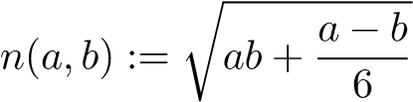.
Observe that n(a,a) = a. If a 6= b then n(a,b) may or may not lie in N. We define
M := {n(a,b)|a,b ∈ N,a 6= b,n(a,b) ∈ N} ⊆ N.
Theorem. Let n ∈ N. Then 6n − 1 and 6n + 1 are twin primes if and only if n ∈6 M.
Proof. Let 6n−1 and 6n+1 be twin primes. Let us assume that n ∈ M. Then there are a,b ∈ N,a 6= b, such that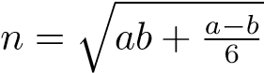. In particular, 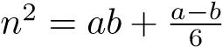, which implies
(6n − 1)(6n + 1) = 36n² − 1 = 36ab + 6a − 6b − 1 = (6a − 1)(6b + 1).
Since 6n − 1 and 6n + 1 are primes, clearly 6n − 1 = 6a − 1 and 6n + 1 = 6b + 1. Hence, n = a = b contradicting a 6= b. This shows that n 6∈ M.
Conversely, let 6n − 1 and 6n + 1 not be twin primes.
Case 1: 6n − 1 is not prime. All of its prime factors have the form 6k±1, with an odd number of them

being of the form 6k − 1. Thus we may write
6n − 1 = (6a − 1)(6b + 1)
for some a,b ∈ N (for instance by choosing 6a − 1 as one of the prime factors of the form 6k − 1 and 6b + 1 as the product of all other prime factors). We let
c := 6an + a − n.
Then c > n > b, so in particular c 6= b. We obtain
36n² − 1 = (6n − 1)(6n + 1) = (6a − 1)(6b + 1)(6n + 1) = (6c − 1)(6b + 1) = 36bc + 6c − 6b − 1
by definition of c, yielding
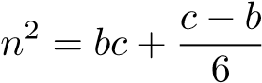 or 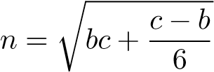.
Therefore, n ∈ M.
Case 2: 6n + 1 is not prime. Again, all of its prime factors have the form 6k ± 1. But now an even

number (or none) of them has the form 6k − 1. Thus we may write
6n + 1 = (6a + 1)(6b + 1) or 6n + 1 = (6a − 1)(6b − 1)
for some a,b ∈ N. (If no prime factor has the form 6k − 1 then we may obviously factorize in the first way. Otherwise, we may factorize in the second way by choosing 6a − 1 as one of the prime factors of the form 6k − 1 and 6b − 1 as the product of all other prime factors.)
1
Case 2.1: 6n + 1 = (6a + 1)(6b + 1) Then we let

c := 6an + n − a
and infer c > n > b and n ∈ M like in case 1.
Case 2.2: 6n + 1 = (6a − 1)(6b − 1) W.l.o.g. b ≤ a. We let

c := 6an − n − b
and again infer c > n > b and n ∈ M like in case 1.
In any case we have shown that n ∈ M, which completes the proof.

